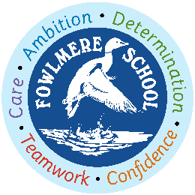
Class 4 2021 – 2022 curriculum content on a page
Autumn 2021 | Spring 2022 | Summer 2022
Reading
Writing
Maths
CUSP Art and Design  Drawing and painting  Printmaking | Textiles and collage  3D | NEW module  School study or revisit previous module and sophisticate / elaborate
Computing  Scratch  Online safety Y5 | Online Safety  Filmmaking | 3D Modelling Sketch Up Make  Controlling device - Flowol
Design and Technology  Funky Furnishings | Building Bridges | Burgers
CUSP Geography  Latitude and Longitude  World countries – biomes and environmental regions | 4 and 6 figure grid references | Revisit world countries – biomes and environmental regions  NEW OS maps and fieldwork
CUSP History  Ancient Greeks | The Struggle or the Kingdom of England – focus on Anglo Saxons  Comparison study – Maya and Anglo-Saxons. | Comparison study – Maya and Anglo-Saxons.
Music  Livin’ on a Prayer (Charanga)  Christmas songs and music | Music  Classroom Jazz1  Make You Feel My Love | Music  The Fresh Prince of Be Air  Dancing in the Street
MfL  Spanish | MfL  Spanish | MfL  Spanish
PE  Football  Rugby  Dance – On the Beach  Gymnastics – Group Work | PE  Netball  Quicksticks hockey  Cricket  Outdoor Adventurous Activities | PE  Tennis  Athletics  Swimming
PSHE  Beginning and Belonging  Family and Friends  Anti-Bullying | PSHE  Diversity and Communities  Sex and Relationship Education  Drug Education | PSHE  Personal Safety  Managing Change
RE  Buddhism | What is it like to be a Christian in the Diocese of Vellore?  Is the Bible like a handbook? | Hinduism - stories, Gods and Goddesses  What can we learn from stories shared by Christians, Jews and Muslims?
CUSP Science  Properties and changes of materials  Animals, including humans | Earth in space  Forces | Living things and their habitats  Forces continued

