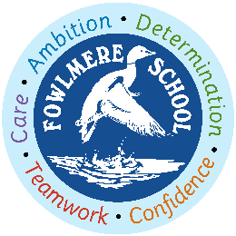
Class 3 2021-2022 Curriculum content on a page
Autumn 2021 | Spring 2022 | Summer 2022
Reading
Writing
Maths
CUSP Art and Design  Drawing and painting  Printmaking | Textiles and collage  3D | NEW module  School study or revisit previous module and sophisticate / elaborate
Computing  Internet research and communication  Drawing and Desktop publishing | Programming Turtle logo and Scratch  Presentation Skills | Word Processing  Online Safety
Design and Technology  Seasonal Stockings | Making mini greenhouses | Seasonal Food
CUSP Geography  Fieldwork and map skills  Human and physical features | UK Study | Revisit human and physical features  OS maps and scale
CUSP History  Stone Age – Iron Age | Stone Age – Iron Age  Rome and the impact on Britain | Rome and the impact on Britain
Music  Mama Mia (Charanga)  Christmas Songs and Music | Music  Glockenspiel 1 (Charanga)  The Dragon Song (Charanga) | Music  Glockenspiel 2 (Charanga)  Bringing us together (Charanga)
MfL  Spanish | MfL  Spanish | MfL  Spanish
PE  Hockey  Rugby  Dance – Machines  Gymnastics – Principles of balance | PE  Football  Orienteering  Handball  Striking and Fielding (Cricket) | PE  Athletics  Net games  Tennis  Swimming
PSHE  Beginning and Belonging  Family and Friends  Anti-Bullying | PSHE  Diversity and Communities  Sex and Relationship Education  Drug Education | PSHE  Personal Safety  Managing Change
RE  Why is prayer important to Muslims and not for some people?  Key beliefs and practices of Islam | Fairness in a global context (Christianity)  The Church Year: Is Easter a festival of new life or sacrifice? | Why do people go on pilgrimages?  Beliefs and practices -Hinduism
CUSP Science  Rocks  Animals, including humans  Revisit Rocks | Forces and magnets  Light | Plants

