English
- We will be exploring a range of traditional tales with a twist, initially concentrating on ‘Jim and the Beanstalk’. We will then write our own traditional tale with a twist.
- We will also write a set of instructions detailing how to grow our own magical beanstalk.
- We will read and discuss poems based on traditional tales and then write and perform a poem of our own.
- Extend our knowledge of spelling, punctuation and grammar.
- Read regularly and continue to work on joining our handwriting.

P.S.H.E.
We will be looking at what it means to treat others with respect and to be treated the same way. We will also explore why we need rules at home and at school and how we can be part of making and changing these rules.
Science
We will be exploring the digestive system by using models to understand the function of key organs and how food is processed in the body.

Music
We will be following the Charanga Music scheme and working on ‘Hands, Feet, Heart’.

R.E.
We will be considering ideas about how we should treat others and look for guidance in Christian, Jewish and Islamic religious texts.

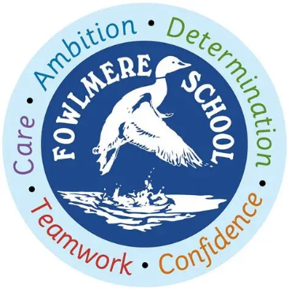
Fowlmere Primary School

Goldfinches Class (Years 3/4)

Curriculum Map Autumn Term 1

Maths
- We will learn how to represent and partition numbers up to 10,000.
- We will learn how to estimate, compare and order numbers to 10,000 and to round numbers to the nearest 10, 100 or 1,000.
- We will investigate and manipulate Roman numerals.
- We will apply our mathematical understanding to solve reasoning problems.
P.E.
We will be improving our ball skills when working outside and, when learning inside, we will be refining our control and flexibility in gymnastics.
Art / D.T.
In Art, we will be looking at patterns in nature and then develop our ideas to produce a repeated print pattern using a motif.
In D.T. we will explore pneumatic systems and then design, build and evaluate our own pneumatic toys.

Spanish
We will be exploring Spanish culture and traditions whilst learning how to greet one another, introduce ourselves and count from 0-10.
History
We will be learning about Anglo-Saxon invaders, starting with who they were and where they came from. We will then explore Anglo-Saxon life, culture and Gods and finish the topic by discussing the Anglo-Saxon royal burial site at Sutton Hoo and the archaeological site at West Stow, both situated in Suffolk.

