English
- We will be using ‘The Iron Man’ by Ted Hughes as a stimulus for our writing this half term. We will produce our own narratives and persuasive writing based on this text.
- We will extend our knowledge of spelling, punctuation and grammar.
- We will continue to read regularly and to join our handwriting correctly.

Science
We will be exploring electrical components and conductivity through circuit building and real-life applications.

P.S.H.E.
We will be considering the qualities of a good friend and understand that healthy friendship is based on trust and mutuality.
We will also join in with national and local initiatives throughout Anti—Bullying Week (16th-20th Nov.)

Spanish
We will continue to explore Spanish culture whilst learning how to follow classroom instructions and name parts of the body in Spanish.

R.E.
We will be exploring ideas relating to the Bible including its structure and authors. We will also consider several distinct types of writing within the Bible and how Christians use their sacred text.

Music
We will be following the Charanga Music scheme, working on ‘Ho Ho Ho.’

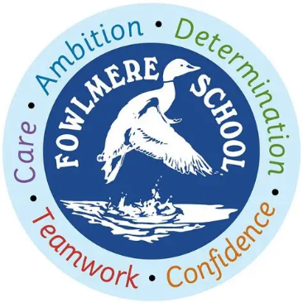
Fowlmere Primary School

Goldfinches Class (Years 3/4)

Curriculum Map Autumn Term 2

Maths
- We will learn about addition and subtraction involving numbers with up to four digits.
- We will learn how to use the inverse and estimation to support our calculations.
- We will learn to correctly identify a range of 2D and 3D shapes, turns and angles.
- We will apply our mathematical understanding to solve reasoning problems.
Computing
We will continue our work on coding using Espresso Coding, focusing on sequences, animation and variables. We will also learn more about online safety with a focus on cyber-bullying and safe internet searches.

Geography
We will be learning about rainforests including where they are found and their structure. We will investigate the climate of rainforests, the people who live there and why these areas are under threat.
P.E.
We will be improving our hockey skills when working outside and, when learning inside, we will learn how to perform, combine and refine movement phrases to produce a dance performance.
Art
In Art, we will be looking at patterns in nature and then develop our ideas to produce a repeated print pattern using a motif.

